Reconciliation & Verification Tool (Tool 1) — Phase 1 Task List
Oct 13, 2026 · @Unnati
The Phase 1 product goes from today to a go/no-go decision on Jan 27, 2027: 61 working days of build in 9 sprints, a two-week pilot at the CA firm, and the decision on the first working day after it. Tracker lead: Unnati, who also runs every sprint demo. Build tasks are owned by the developer, working 8–9 hours a day with Claude Code and with Claude agents for testing and peer review. Week 1 is reconciliation only.

Timeline
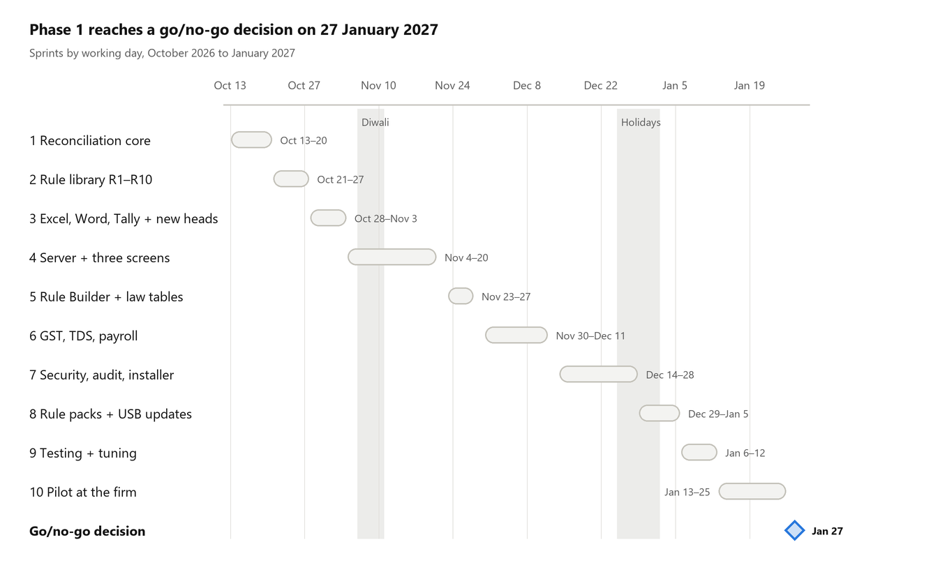
Phase 1 timeline · 13 Oct 2026 to 27 Jan 2027
Working days are Monday to Friday. Diwali (6–10 November), 25 December, 1 January and 26 January are left out. Building ends on 12 January; the pilot runs from 13 to 25 January, so the decision lands on 27 January.

Week 1: Prerequisites and Sprint 1 Reconciliation core (13–20 Oct)
Start everything with an outside wait on day one. The build is reconciliation only, from the command line: files in, hand-written rules, findings out. No UI, login or voice.
# | Task | Owner | Due | Status
1 | Confirm the Claude Code plan covers full-day sessions plus the testing and review agents | Unnati | Oct 13, 2026 | Not started
2 | Ask the firm for the tax-suite name, version and anonymised JSON samples (Q1) | Unnati | Oct 13, 2026 | Not started
3 | Ask the firm for the Excel and Word staff documents (Q2) and the Tally version and export steps (Q3) | Unnati | Oct 13, 2026 | Not started
4 | Book the CA: read the Week 1 rules on Oct 19, review rules weekly from Oct 21, confirm ₹10 rounding of negative amounts | Unnati | Oct 14, 2026 | Not started
5 | Book the Windows test PC and a named person to run each build (Q5) | Unnati | Oct 16, 2026 | Not started
6 | SPEC-001: first CI run green on GitHub; mark Done | Developer | Oct 13, 2026 | In progress
7 | SPEC-004: fact vocabulary | Developer | Oct 13, 2026 | Done
8 | SPEC-005: ingestion framework and JSON adapter (amounts read as exact text, never decimals) | Developer | Oct 13, 2026 | Not started
9 | SPEC-006: format profiles for the generic tax-suite computation and tax audit report, two samples each | Developer | Oct 14, 2026 | Not started
10 | SPEC-010: SQLite fact store; driver choice recorded in docs/adr | Developer | Oct 14, 2026 | Not started
11 | SPEC-007: strict YAML rule loader and rule-lint | Developer | Oct 15, 2026 | Not started
12 | Write RECON-DEP-002 and RECON-DEP-001 by hand, with passing and failing test files | Developer | Oct 15, 2026 | Not started
13 | Add 3 to 8 more same-figure (R1) rules chosen with the CA; add their facts to the vocabulary first | Developer | Oct 15, 2026 | Not started
14 | SPEC-008: rule engine with the "equal" check; "Cannot check" for missing figures | Developer | Oct 16, 2026 | Not started
15 | SPEC-009: finding wording; text and JSON report grouped by document; golden file | Developer | Oct 16, 2026 | Not started
16 | SPEC-011: recon-engine run command end to end on the reference and clean packs | Developer | Oct 19, 2026 | Not started
17 | Testing agent checks every acceptance criterion of SPEC-005 to 011; review agent reviews each spec; fixes applied | Developer | Oct 19, 2026 | Not started
18 | Run the Windows .exe on the test PC; output matches the developer's run | Windows tester | Oct 19, 2026 | Not started
19 | CA reads the hand-written Week 1 rules | Firm's CA | Oct 19, 2026 | Not started
20 | Gate G1: demo of the reference pack giving the depreciation finding, and the clean pack giving zero findings | Unnati | Oct 19, 2026 | Not started
21 | Buffer: finish carry-over; if ahead, SPEC-018 Excel/CSV adapter | Developer | Oct 20, 2026 | Not started

Sprint 2: Rule library R1–R10 (21–27 Oct)
By 27 October all ten reference defect types are caught from the synthetic filing pack, with zero false findings.
# | Task | Owner | Due | Status
1 | SPEC-012: scalar checks (sum_equals, gte, field_present, domain) | Developer | Oct 21, 2026 | Not started
2 | SPEC-013: law tables with as-of-date lookup | Developer | Oct 22, 2026 | Not started
3 | SPEC-014: Starlark formula rules (no floats, step limit) | Developer | Oct 23, 2026 | Not started
4 | SPEC-015: draft history and draft comparison | Developer | Oct 26, 2026 | Not started
5 | SPEC-016: starter rules for R1–R10, each with passing and failing test files | Developer | Oct 27, 2026 | Not started
6 | SPEC-017: determinism check, incremental re-run and performance benchmark in CI | Developer | Oct 27, 2026 | Not started
7 | CA reviews the starter rules as they land | Firm's CA | Oct 27, 2026 | Not started
8 | Gate G2: demo of all ten defect types caught with zero false findings | Unnati | Oct 27, 2026 | Not started

Sprint 3: Excel, Word, Tally and new heads (28 Oct–3 Nov)
Staff Excel and Word files and Tally exports are read, and last year's ledgers are compared with this year's. Needs the Q2 and Q3 samples by 28 October.
# | Task | Owner | Due | Status
1 | SPEC-018: Excel/CSV adapter, if not done on Oct 20; excelize passes the network-code check | Developer | Oct 28, 2026 | Not started
2 | SPEC-019: Word table adapter; library chosen after the network-code check | Developer | Oct 29, 2026 | Not started
3 | SPEC-020: Tally XML adapter and record store | Developer | Nov 2, 2026 | Not started
4 | SPEC-021: new-head detection and Worklist | Developer | Nov 3, 2026 | Not started
5 | Testing and review agents pass on SPEC-018 to 021 | Developer | Nov 3, 2026 | Not started
6 | Demo: Worklist built from two years of ledgers lists every new, vanished and changed head | Unnati | Nov 3, 2026 | Not started

Sprint 4: Server and three screens (4–20 Nov)
Ten working days around Diwali to put the engine behind a login and three screens on the office network.
# | Task | Owner | Due | Status
1 | Confirm how many staff will use the tool at the same time (Q6) | Unnati | Nov 4, 2026 | Not started
2 | SPEC-022: recon-server with login and roles | Developer | Nov 5, 2026 | Not started
3 | CA signs off the finding states, including "withdrawn" | Firm's CA | Nov 11, 2026 | Not started
4 | SPEC-023: job queue, engine supervision and server-engine messages; load test | Developer | Nov 13, 2026 | Not started
5 | SPEC-024: clients, engagements, uploads, vault and drafts | Developer | Nov 16, 2026 | Not started
6 | SPEC-025: findings lifecycle and staff decisions | Developer | Nov 18, 2026 | Not started
7 | SPEC-026: Season board, Client file and Worklist screens | Developer | Nov 20, 2026 | Not started
8 | Demo: staff log in from a second PC, upload files and decide findings; a corrected upload resolves the finding | Unnati | Nov 20, 2026 | Not started

Sprint 5: Rule Builder and law tables (23–27 Nov)
The CA can write and test rules without touching YAML, and the Partner approves them.
# | Task | Owner | Due | Status
1 | Decide who may disable a rule: Partner only, or Managers too | Partner | Nov 23, 2026 | Not started
2 | SPEC-027: rule and law-table governance; Rule Builder form; rule test on a past client | Developer | Nov 26, 2026 | Not started
3 | SPEC-028: Format Register and vocabulary browser | Developer | Nov 27, 2026 | Not started
4 | Demo: the CA creates a rule on the form and tests it on a past client; the Partner activates it | Unnati | Nov 27, 2026 | Not started

Sprint 6: GST, TDS and payroll (30 Nov–11 Dec)
Row-level matching of books against portal, TRACES, EPF and ESIC files.
# | Task | Owner | Due | Status
1 | Collect anonymised GST portal, TRACES, EPF ECR and ESIC sample files | Unnati | Nov 27, 2026 | Not started
2 | SPEC-029: record matching with date, threshold and period checks | Developer | Dec 2, 2026 | Not started
3 | SPEC-030: PDF and fixed-width adapters | Developer | Dec 4, 2026 | Not started
4 | SPEC-044: refuse photos and scanned PDFs; no OCR | Developer | Dec 7, 2026 | Not started
5 | SPEC-031: GST reconciliation module | Developer | Dec 8, 2026 | Not started
6 | SPEC-032: TDS reconciliation module | Developer | Dec 10, 2026 | Not started
7 | SPEC-033: payroll reconciliation module | Developer | Dec 11, 2026 | Not started
8 | Demo: gaps found on test GST, TDS, ECR and ESIC files; a scanned PDF is refused | Unnati | Dec 11, 2026 | Not started

Sprint 7: Security, audit and installer (14–28 Dec)
Everything needed before real client files are uploaded: encryption, roles, audit log, backups, exports and the installer.
# | Task | Owner | Due | Status
1 | Decide the HTTPS certificate on staff PCs, and whether to keep a licence check (Q4) | Partner | Dec 14, 2026 | Not started
2 | Office desktop, two backup drives and a UPS in place | Unnati | Dec 14, 2026 | Not started
3 | SPEC-034: database and file encryption; key sealing and recovery code | Developer | Dec 15, 2026 | Not started
4 | SPEC-035: HTTPS, sessions and full role matrix | Developer | Dec 16, 2026 | Not started
5 | SPEC-036: hash-chained audit log | Developer | Dec 17, 2026 | Not started
6 | SPEC-037: backup and restore | Developer | Dec 18, 2026 | Not started
7 | SPEC-038: Excel, watermarked PDF and client query letter exports | Developer | Dec 21, 2026 | Not started
8 | SPEC-039: client export, deletion and retention | Developer | Dec 22, 2026 | Not started
9 | SPEC-040: Windows installer and portable zip | Developer | Dec 24, 2026 | Not started
10 | Demo: security checklist passes, a backup is restored on a second machine, and the installer sets up a clean PC | Unnati | Dec 28, 2026 | Not started

Sprint 8: Rule packs and updates by USB (29 Dec–5 Jan)
Rules and the program itself can be updated without internet, and every update can be rolled back.
# | Task | Owner | Due | Status
1 | SPEC-041: signed content packs: verify, install, conflict check, rollback | Developer | Dec 31, 2026 | Not started
2 | SPEC-042: binary updater | Developer | Jan 5, 2027 | Not started
3 | Demo: a signed pack is installed from USB and rolled back; a tampered pack is rejected | Unnati | Jan 5, 2027 | Not started

Sprint 9: Testing and tuning (6–12 Jan)
The full synthetic test set decides whether the product is ready for the pilot.
# | Task | Owner | Due | Status
1 | Run the full synthetic test set and write the results | Developer | Jan 6, 2027 | Not started
2 | Measure speed with 200,000 vouchers and 50 clients | Developer | Jan 7, 2027 | Not started
3 | Disable any rule that fires wrongly; do not tune it | Developer | Jan 8, 2027 | Not started
4 | Sign off the starter rules and law-table values | Firm's CA | Jan 8, 2027 | Not started
5 | Confirm the pilot staff and the 5 real client files | Unnati | Jan 8, 2027 | Not started
6 | Gate G3: demo of test results against targets (R1–R10 with zero false findings, fewer than 5 on a clean file, speed) | Unnati | Jan 12, 2027 | Not started

Sprint 10: Pilot and go/no-go (13–27 Jan)
Staff use the tool on real client files on the firm's own desktop for two weeks; the decision on production use and later phases is made on 27 January.
# | Task | Owner | Due | Status
1 | Install on the firm's main desktop; create users; apply the starter rule pack by USB | Developer | Jan 13, 2027 | Not started
2 | Run the clean and reference packs on the installed desktop before any real file | Developer | Jan 13, 2027 | Not started
3 | Staff run the tool on at least 5 real client files in the office | Firm staff | Jan 20, 2027 | Not started
4 | Fix blocking issues the same day; disable any rule that fires wrongly | Developer | Jan 22, 2027 | Not started
5 | Collect feedback with a short form | Unnati | Jan 25, 2027 | Not started
6 | Write the go/no-go report against the BRD success criteria | Unnati | Jan 25, 2027 | Not started
7 | Gate G4: demo and go/no-go decision for production use and later phases | Unnati | Jan 27, 2027 | Not started

Dates at risk
Each risk below has a fallback that keeps the 27 January date.
Risk | Fallback
Real tax-suite JSON samples arrive late (Q1) | Build on the generic synthetic formats; real profiles are added later as new folders, with no code change
Week 1 overruns: eight specs and the first rules in five days | Oct 20 is buffer; the Excel stretch moves to Sprint 3 without moving any date
Windows test PC not ready by Oct 19 | CI builds the Windows .exe on every push; run it on the PC the day it arrives
CA not available for rule review | Rules stay inactive until approved; book the CA's Week 1 and weekly review slots now
A library brings in network code (excelize, Word reader, SQLCipher driver) | The architecture guard catches it on push; swap the library or move that step to a helper program
Encrypted database complicates the Windows build | Plain SQLite behind the same interface until Sprint 7; Windows build checked in CI
Holidays: Diwali (6–10 Nov), 25 Dec, 1 Jan and 26 Jan | Already left out of the working days; no sprint depends on a holiday
A finding in the pilot is a false alarm | Disable the rule the same day, record it, and count it against the 2-per-100 target
Real client data reaches the repository or Claude | Synthetic data only while building; pilot files stay on the firm's desktop

